We Are Not Under The Law!

They say that we are not under The Law. And they are right!
But if you are led by the Spirit, you are not under Law. Galatians 5:18
Spirit led people are no longer captive. We are free!
In many countries we are free too. Though we are subject to the laws of the land where we live. If we break the laws of the land, we can be taken in under the law, where we will be tried, convicted and sentenced according to the laws of that land. That’s why we don’t break the law!
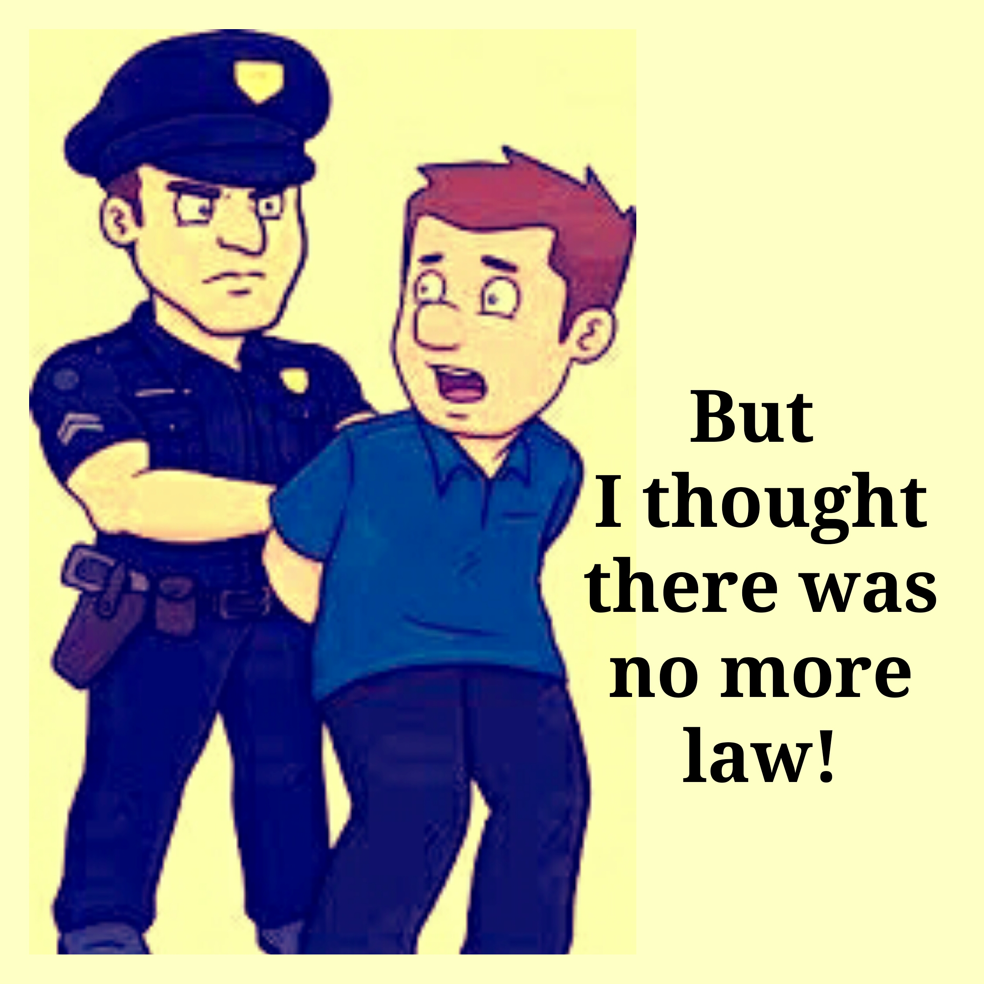
In a just society, if we never break The Law, we will never be taken in under The Law.
The Kingdom of God is a just society and no one breaks The Law there. Otherwise, it wouldn’t be Heaven! Would it? How would God like it if people broke His Laws right where He lives?
People in Heaven love God so, they keep His Commandments, just like Jesus did.
If you keep My commandments, you shall abide in My love, even as I have kept My Father's Commandments and abide in His love. John 15:10
And people who want to break The Law just won't be there. That makes sense, doesn’t it?
For I say to you that unless your righteousness shall exceed that of the scribes and Pharisees, you shall in no case enter into the kingdom of Heaven. Matthew 5:20
God has allowed us time to learn The Law which He commanded through Moses. But, the penalty for breaking those laws is death.

For the wages of sin is death, but the gift of God is eternal life through Jesus Christ our Lord. Romans 6:23

And thankfully, since we are not dead yet, we are not under The Law!
But when we die we will be tried, according to our works on Judgment Day.
And I saw the dead, the small and the great, stand before God. And books were opened, and another book was opened, which is the Book of Life. And the dead were judged out of those things which were written in the books, according to their works. Revelation 20:12
But according to your hardness and your impenitent heart, do you treasure up wrath for yourself in a day of wrath and revelation of the righteous judgment of God, who will render to each according to his works. Romans 2:5-6
Failure to please God has serious consequences.
And if anyone was not found having been written in the Book of Life, he was cast into the Lake of Fire. Revelation 20:12
But, if we have followed Christ’s example and obeyed the Father, as He did;
If you keep My commandments, you shall abide in My love, even as I have kept My Father's Commandments and abide in His love." John 15:10
If we trust His sacrifice to pay for our mistakes;
By this will we are sanctified through the offering of the body of Jesus Christ once for all." Hebrews 10:10
If we work our Salvation through Faith and good works;
Therefore, my beloved, as you have always obeyed, not as in my presence only, but now much more in my absence, cultivate your own salvation with fear and trembling. Philippians 2:12
Then we will receive the inheritance of the Grace of God.
And now, brothers, I commend you to God, and to the word of His Grace, which is able to build you up and to give you an inheritance among all those who are sanctified. Acts 20:3
And because God loves us so much, the penalty for the laws we broke are waived and we are granted Eternal Life!
For God so loved the world that He gave His only begotten Son, that whoever believes in Him should not perish but have everlasting life. John 3:16
That’s the Good News! Messiah’s death is accepted on our behalf and the penalty for our sins is paid in full. Messiah is the Hebrew word for Christ.
Christ redeemed us from the curse of the Law, being made a curse for us… Galatians 3:13
This is our Faith! But Faith requires action.
Even so, if it does not have works, faith is dead, being by itself. But someone will say, You have faith, and I have works. Show me your faith without your works, and I will show you my faith from my works. You believe that there is one God, you do well; even the demons believe and tremble. But will you know, O vain man, that faith without works is dead? Was not Abraham our father justified by works when he had offered Isaac his son upon the altar? Do you see how faith worked with his works, and from the works faith was made complete? And the Scripture was fulfilled which says, Abraham believed God, and it was imputed to him for righteousness, and he was called the friend of God. You see then how a man is justified by works, and not by faith only. And in the same way, was not Rahab the harlot also justified by works when she had received the messengers and had sent them out another way? For as the body without the spirit is dead, so faith without works is dead also. James 2:14-26
So, if we refuse to follow Messiah’s example; refuse to obey The Law He obeyed, refuse to exercise our Faith by sharing His Word with others,- we will be tried, convicted and sentenced according to The Law of God.
Even if we have cast out demons, prophesied and did many miraculous things, in His name, we will not be permitted to enter the Kingdom of God; no matter how many times we cry out “Lord, Lord”!
Not everyone who says to Me, Lord! Lord! shall enter the kingdom of Heaven, but he who does the will of My Father in Heaven. Many will say to Me in that day, Lord! Lord! Did we not prophesy in Your name, and through Your name throw out demons, and through Your name do many wonderful works? And then I will say to them I never knew you! Depart from Me, those working lawlessness! Matthew 7:21-23
This is what will happen if we do not become willing to subject ourselves to The Law of God.
And unfortunately, our time is almost over.
Take heed that no man deceive you. For many will come in My name, saying, I am Christ, and will deceive many. And you will hear of wars and rumors of wars. See that you are not troubled, for all these things must occur; but the end is not yet. For nation will rise against nation, and kingdom against kingdom. And there will be famines and pestilences and earthquakes in different places. All these [are] the beginning of sorrows. Then they will deliver you up to be afflicted and will kill you. And you will be hated of all nations for My name's sake. And then many will be offended, and will betray one another, and will hate one another.
And many false prophets will rise and deceive many. And because iniquity shall abound, the love of many will become cold. But he who endures to the end, the same shall be kept safe." Matthew 24:5-13
Soon our Saviour will return to destroy all the lawlessness on the Earth. Even now we see that the end is near.

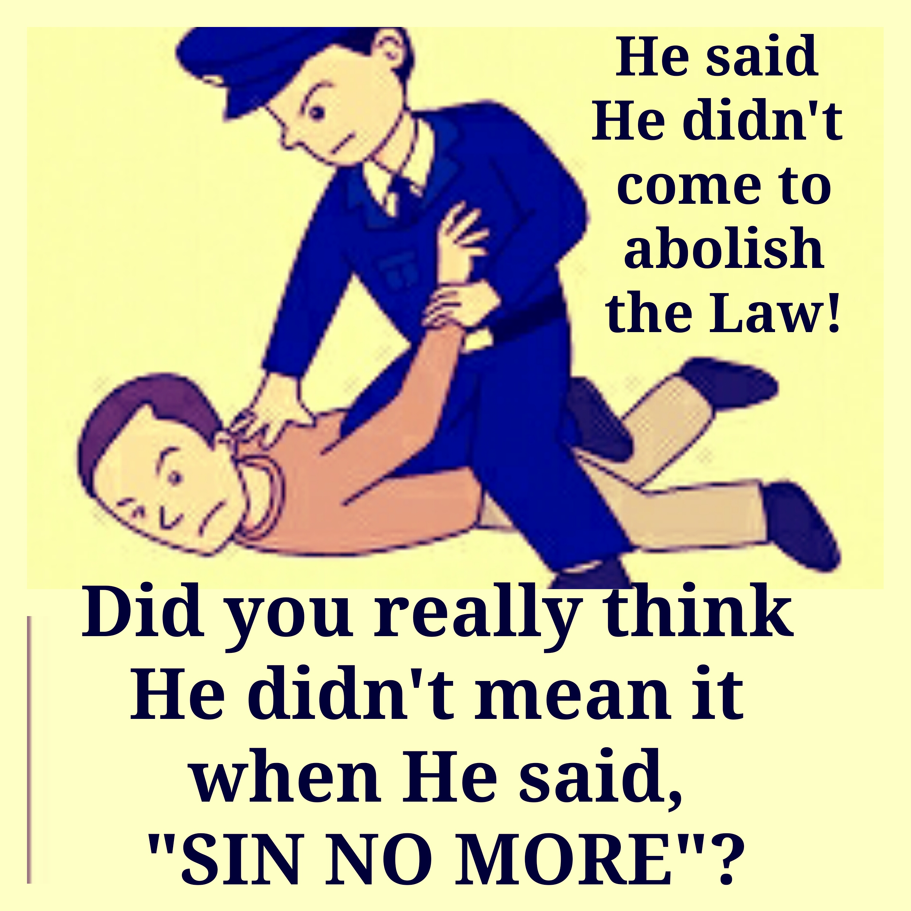

So, we need to stop trampling on the blood of Messiah and insulting the Grace of God.
He who despised Moses' law died without mercy on the word of two or three witnesses. Of how much worse punishment, do you suppose, will he be thought worthy of punishment, the one who has trampled the Son of God, and who has counted the blood of the covenant with which he was sanctified an unholy thing, and has insulted the Spirit of grace?
Hebrews 10:28-29
We need to repent and keep all of the commandments. Not just the ones we like!
Or do you despise the riches of His kindness, and the forbearance and longsuffering, not knowing that the kindness of God leads you to repentance? Romans 2:4
We need to trust Messiah’s sacrifice to cover our shortcomings and show our gratitude by obeying God. And we need to love one another.
By this all shall know that you are My disciples, if you have love toward one another. John 13:35
You shall not avenge, nor bear any grudge against the sons of your people; but you shall love your neighbor as yourself. I am the LORD. Leviticus 19:18
We need to open our hearts to the sick, the aged, the poor and the needy! We need to reach out and help!
He who has pity upon the poor lends to the LORD, and He will reward his dealing to him. Proverbs 19:17
He who has a bountiful eye shall be blessed; for he gives of his bread to the poor. Proverbs 22:9
So, let’s meet with Our Heavenly Father - every Sabbath Day - to be nurtured and instructed by Him.
After all, that’s what The Law says, isn’t it?
Remember the Sabbath Day to keep it Holy, Exodus 20:8
Besides, when we let God nurture us on the Sabbath, we become more like His Son!
For let this mind be in you which was also in Christ Jesus, Philippians 2:5
That's what it means to be led by the Spirit. We become like Christ!

It takes courage to face the Truth! We need to face it before it’s too late. Time is short! Let’s face it now and learn our Father’s ways.

So says the LORD, Stand in the ways and see, and ask for the old paths where the good way is,, and walk in it, and you shall find rest for your souls.' But they said, 'We will not walk' in it. Jeremiah 6:16
You will make me know the way of life; in Your presence is fullness of joys. At Your right hand are pleasures forevermore." Psalms 16:11
In Him we have redemption through His blood, the forgiveness of sins, according to the riches of His grace, Ephesians 1:7
who gave Himself for our sins, that He might deliver us from this present evil world according to the will of God and our Father Galatians 1:4
I have blotted out, as a thick cloud, your transgressions, and, as a cloud, your sins; return to Me; for I have redeemed you. Isaiah 44:22
Therefore repent and convert so that your sins may be blotted out when the times of refreshing shall come from the presence of the Lord. Acts 3:19
He sent redemption to His people; He has commanded His covenant forever; holy and awesome is His name. Psalms 111:9

He who DESPISED Moses' law DIED WITHOUT MERCY on the word of two or three witnesses. (The Grace of God and the Spirit of Love do not mean that it is acceptable to despise Moses's law now.) Of how much worse punishment, do you suppose, will he be thought worthy of punishment, the one who has trampled the Son of God, (used His Name and Sacrifice to justify breaking God's Law!) and who has counted the blood of the covenant with which he was sanctified an unholy thing, (making Jesus blood serve lawlessness) and has insulted the Spirit of grace (arrogantly dismissing the precious gift of God)? For we know Him who has said, Vengeance belongs to Me, I WILL REPAY, says the Lord. And again, THE LORD SHALL JUDGE HIS PEOPLE. It is a fearful thing to fall into the hands of the living God. Hebrews 10:28-31

The fear of the LORD is the beginning of wisdom; and the knowledge of the holy is understanding. Proverbs 9:10

